 |  | Newsletter
School Name  <Telephone Number>  <Website>  <Email> |  | 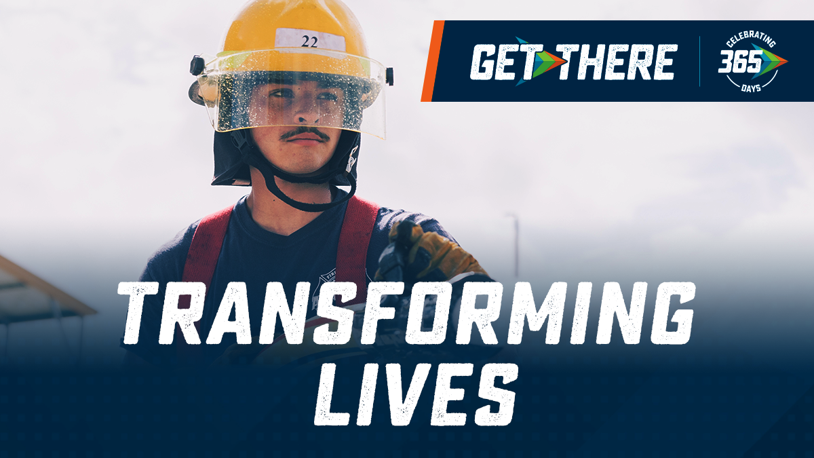
IET Program Offerings & Schedule  <Name of IET>  <Start Date>  <Days and Times of the Week>  <Name of IET>  <Start Date>  <Days and Times of the Week> |  | <School Name> offers rapid credentialing through IET!  Lorem ipsum dolor sit amet, consectetur adipiscing elit. Aliquam non varius ipsum. Fusce venenatis quam vel libero scelerisque, a mattis diam sollicitudin. Lorem ipsum dolor sit amet, consectetur adipiscing elit. Aliquam non varius ipsum. Fusce venenatis quam vel libero sce lerisque, a mattis diam sollicitudin.  Maecenas massa velit, consectetur sit amet da pibus et, dapibus sit amet odio. Vestibulum ultric ies erat sit amet massa ullamcorper ferm entum. Quisque a suscipit nulla, non posuere tellus. Vivamus justo erat, suscipit sit amet ultr icie. Ma ecenas massa velit, consectetur sit amet dapibus et, dapibus sit amet odio. Vestibulum ultricies erat sit amet massa ullamcorper.  Lorem ipsum dolor sit amet, consectetur adipi scing elit. Aliquam non varius ipsum. Fusce ven enatis quam vel libero scelerisque, a mattis diam sollicitudin. Lorem ipsum dolor sit amet, cons ectetur adipiscing elit. Aliquam non varius ipsum. Fusce venenatis quam vel libero sce lerisque, a mattis diam sollicitudin. Quisque a suscipit nulla, non posuere tellus.

Pre-requisites and Exit Criteria
Lorem ipsum dolor sit amet, consectetur adipiscing elit. Aliquam non varius ipsum. Fusce venenatis quam vel libero scelerisque, a mattis diam sollicitudin. Lorem ipsum dolor sit amet, consectetur adipiscing elit. Aliquam non varius ipsum. Fusce venenatis quam vel libero scelerisque, a mattis diam sollicitudin.
Maecenas massa velit, consectetur sit amet dapibus et, dapibus sit amet odio. Vestibulum ultricies erat sit amet massa ullamco rper ferme ntum. Quisque a suscipit nulla, non posuere tellus. Viva mus justo erat, suscipit sit amet dui sed, ultricies porttitor mi.
Aliquam pharetra risus vitae odio imperdiet condimentum. Fusce in quam varius, dictum mi sit amet, aliquam mi. Suspe ndisse potenti. Pellentesque auctor id neque vel maximus.
IET Program Highlights  Lorem ipsum dolor sit amet, consec tetur adi piscing elit. Aliquam non varius ipsum. Fusce venenatis quam vel libero scelerisque. Quam vel libero sce lerisque, a matm.  Lorem ipsum dolor sit amet, consec tetur adi piscing elit. Aliquam non varius ipsum. Fusce venenatis quam vel libero scelerisque. Quam vel libero sce lerisque, a mattis diam venenatis quam vel. |  | 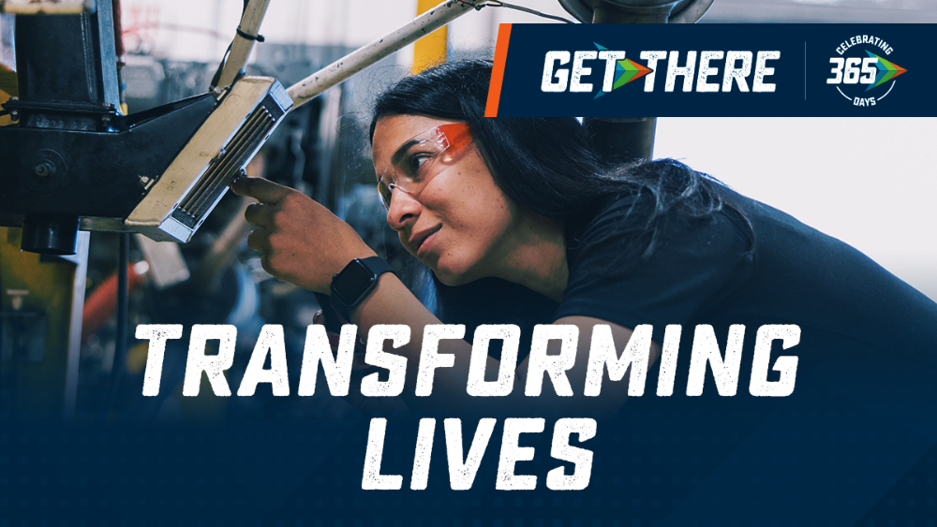
Funding Sources & Support Services
Lorem ipsum dolor sit amet, consectetur adipiscing elit. Ma ecenas massa velit, consectetur sit amet dapibus et, dapibus sit amet odio. Aliquam non varius ipsum. Fusce venenatis quam vel libero scelerisque, a mattis diam sollicitudin. Lorem ipsum dolor sit amet, consectetur adipiscing elit. Non varius ipsum. Fusce venenatis quam vel libero sce lerisque, a mattis.
Maecenas massa velit, consectetur sit amet da pibus et, dapibus sit amet odio. Vestibulum ultric ies erat sit amet massa ullamcorper ferm entum. Quisque a suscipit nulla, non posuere tellus. Vivamus justo erat, suscipit sit amet ultr icie. Ma ecenas massa velit, consectetur sit amet dapibus et, dapibus sit amet odio. Vestibulum ultricies erat sit amet massa ullamcorper. nulla, non posuere tellus. Vivamus justo erat, suscipit sit amet dui sed, ultricie. Ma ecenas massa velit.

 |  | Newsletter
School Name
<Telephone Number>
<Website>
<Email>

IET Program Offerings  <Name of IET>  <Start Date>  <Days and Times of the Week>  <Name of IET>  <Start Date>  <Days and Times of the Week> |  | <School Name> offers rapid credentialing through IET!  Lorem ipsum dolor sit amet, consectetur adipiscing elit. Aliquam non varius ipsum. Fusce venenatis quam vel libero scelerisque, a mattis diam sollicitudin. Lorem ipsum dolor sit amet, consectetur adipiscing elit. Aliquam non varius ipsum. Fusce venenatis quam vel libero sce lerisque, a mattis diam sollicitudin.  Maecenas massa velit, consectetur sit amet da pibus et, dapibus sit amet odio. Vestibulum ultric ies erat sit amet massa ullamcorper ferm entum. Quisque a suscipit nulla, non posuere tellus. Vivamus justo erat, suscipit sit amet ultr icie. Ma ecenas massa velit, consectetur sit amet dapibus et, dapibus sit amet odio. Vestibulum ultricies erat sit amet massa ullamcorper.  Lorem ipsum dolor sit amet, consectetur adipi scing elit. Aliquam non varius ipsum. Fusce ven enatis quam vel libero scelerisque, a mattis diam sollicitudin. Lorem ipsum dolor sit amet, cons ectetur adipiscing elit. Aliquam non varius ipsum. Fusce venenatis quam vel libero sce lerisque, a mattis diam sollicitudin. Quisque a suscipit nulla, non posuere tellus.

Pre-requisites and Exit Criteria
Lorem ipsum dolor sit amet, consectetur adipiscing elit. Aliquam non varius ipsum. Fusce venenatis quam vel libero scelerisque, a mattis diam sollicitudin. Lorem ipsum dolor sit amet, consectetur adipiscing elit. Aliquam non varius ipsum. Fusce venenatis quam vel libero scelerisque, a mattis diam sollicitudin.
Maecenas massa velit, consectetur sit amet dapibus et, dapibus sit amet odio. Vestibulum ultricies erat sit amet massa ullamco rper ferme ntum. Quisque a suscipit nulla, non posuere tellus. Viva mus justo erat, suscipit sit amet dui sed, ultricies porttitor mi.
Aliquam pharetra risus vitae odio imperdiet condimentum. Fusce in quam varius, dictum mi sit amet, aliquam mi. Suspe ndisse potenti. Pellentesque auctor id neque vel maximus.
IET Program Highlights
Lorem ipsum dolor sit amet, consec tetur adi piscing elit. Aliquam non varius ipsum. Fusce venenatis quam vel libero scelerisque. Quam vel libero sce lerisque, a matm.

Lorem ipsum dolor sit amet, consec tetur adi piscing elit. Aliquam non varius ipsum. Fusce venenatis quam vel libero scelerisque. Quam vel libero sce lerisque, a mattis diam venenatis quam vel.
Funding Sources & Support Services
Lorem ipsum dolor sit amet, consectetur adipiscing elit. Ma ecenas massa velit, consectetur sit amet dapibus et, dapibus sit amet odio. Aliquam non varius ipsum. Fusce venenatis quam vel libero scelerisque, a mattis diam sollicitudin. Lorem ipsum dolor sit amet, consectetur adipiscing elit. Non varius ipsum. Fusce venenatis quam vel libero sce lerisque, a mattis.
Maecenas massa velit, consectetur sit amet da pibus et, dapibus sit amet odio. Vestibulum ultric ies erat sit amet massa ullamcorper ferm entum. Quisque a suscipit nulla, non posuere tellus. Vivamus justo erat, suscipit sit amet ultr icie. Ma ecenas massa velit, consectetur sit amet dapibus et, dapibus sit amet odio. Vestibulum ultricies erat sit amet massa ullamcorper. nulla, non posuere tellus. Vivamus justo erat, suscipit sit amet dui sed, ultricie. Ma ecenas massa velit.

