Tools for the ESOL Classroom

Bonnie Goonen – bv73008@aol.com

Susan Pittman – skptvs@aol.com

**Math Graphic Organizer Templates**



**Institute for the Professional Development of Adult Educators**

Math Graphic Organizer Templates

Tools for the ESOL Classroom

Rod Duckworth, Chancellor

Career and Adult Education, Department of Education

Zelda Rogers, Senior Educational Program Director

Adult Education, Career and Adult Education

Philip Anderson, ESOL Program Specialist

Adult Education, Career and Adult Education

June Rall, Director of IPDAE

Tamara Serrano, Project Support Specialist for IPDAE

**Resources Developed and Designed By**

Bonnie Goonen

Susan Pittman

Institute for the Professional Development of Adult Educators



The IPDAE project is supported with funds provided through the Florida Department of Education and Division of Career Adult Education.

Templates for the Classroom

Base 10 Blocks Template 4

Base 10 Blocks - Cut along the solid lines! 5

Fraction Tiles 6

Fraction Blocks 8

Number Line 9

Pattern Block Template 10

Geoboard Template 12

Algebra Tile Template 13

Algebra Tile Template 14

Dice 15

Graph Paper 16

Centimeter Grid Paper 17

Graphic Organizer for Mathematical Problem Solving 18

Problem Solving Graphic Organizer – K-N-W-S 19

Verbal and Visual Word Association (Barton & Heidema, 2002) 20

Vocabulary – Frayer Model 21

## Base 10 Blocks Template

## 

|  |  |  |  |  |  |  |  |  |  |
| --- | --- | --- | --- | --- | --- | --- | --- | --- | --- |
|  |  |  |  |  |  |  |  |  |  |
|  |  |  |  |  |  |  |  |  |  |
|  |  |  |  |  |  |  |  |  |  |
|  |  |  |  |  |  |  |  |  |  |
|  |  |  |  |  |  |  |  |  |  |
|  |  |  |  |  |  |  |  |  |  |
|  |  |  |  |  |  |  |  |  |  |
|  |  |  |  |  |  |  |  |  |  |
|  |  |  |  |  |  |  |  |  |  |
|  |  |  |  |  |  |  |  |  |  |

|  |  |  |  |  |  |  |  |  |  |
| --- | --- | --- | --- | --- | --- | --- | --- | --- | --- |
|  |  |  |  |  |  |  |  |  |  |

|  |  |  |  |  |  |  |  |  |  |
| --- | --- | --- | --- | --- | --- | --- | --- | --- | --- |
|  |  |  |  |  |  |  |  |  |  |

|  |  |  |  |  |  |  |  |  |  |
| --- | --- | --- | --- | --- | --- | --- | --- | --- | --- |
|  |  |  |  |  |  |  |  |  |  |

## **Base 10 Blocks** - Cut along the solid lines!

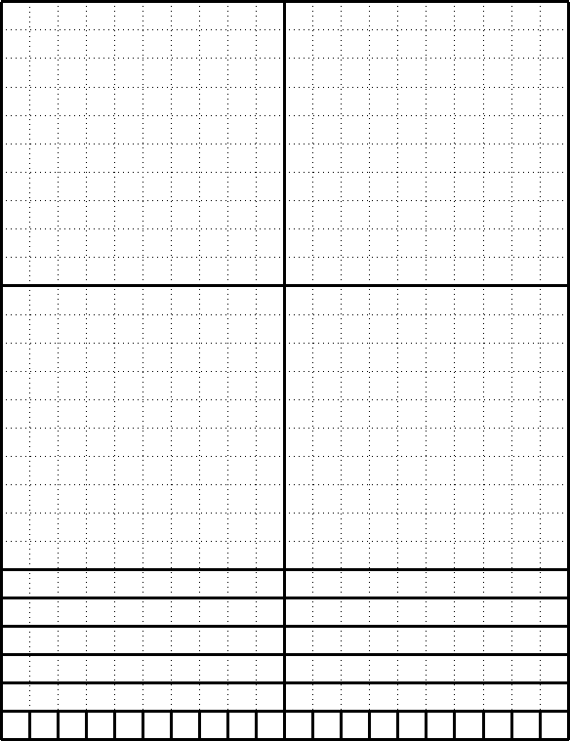

## Fraction Tiles

|  |
| --- |
| 1 |

|  |  |
| --- | --- |
| 1  2 | 1  2 |

|  |  |  |
| --- | --- | --- |
| 1  3 | 1  3 | 1  3 |

|  |  |  |  |
| --- | --- | --- | --- |
| 1  4 | 1  4 | 1  4 | 1  4 |

|  |  |  |  |  |
| --- | --- | --- | --- | --- |
| 1  5 | 1  5 | 1  5 | 1  5 | 1  5 |

|  |  |  |  |  |  |
| --- | --- | --- | --- | --- | --- |
| 1  6 | 1  6 | 1  6 | 1  6 | 1  6 | 1  6 |

|  |  |  |  |  |  |  |  |
| --- | --- | --- | --- | --- | --- | --- | --- |
| 1  8 | 1  8 | 1  8 | 1  8 | 1  8 | 1  8 | 1  8 | 1  8 |

|  |  |  |  |  |  |  |  |  |  |
| --- | --- | --- | --- | --- | --- | --- | --- | --- | --- |
| 1  10 | 1  10 | 1  10 | 1  10 | 1  10 | 1  10 | 1  10 | 1  10 | 1  10 | 1  10 |

## Fraction Blocks

## Number Line

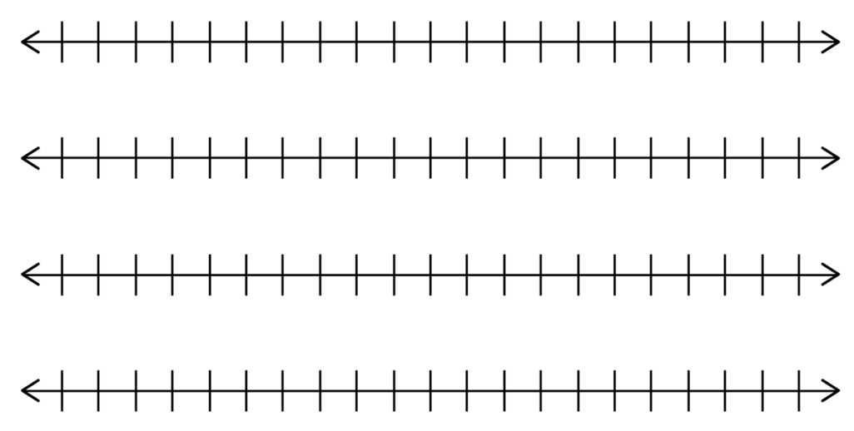

## Pattern Block Template

## Geoboard Template

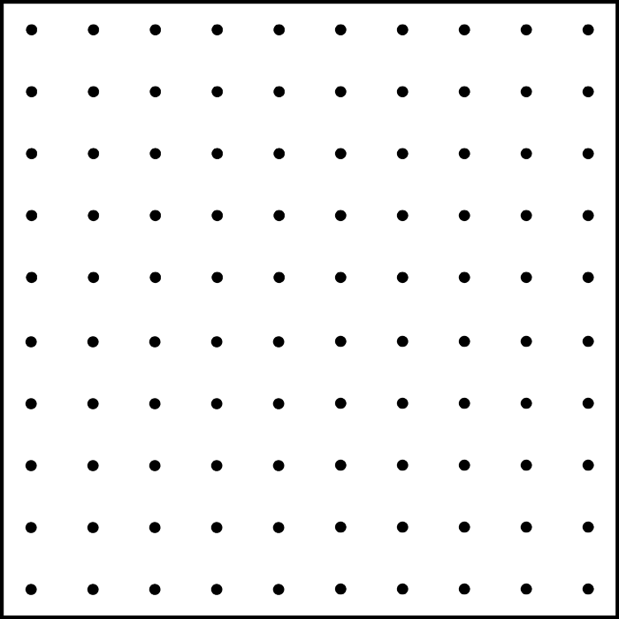

## Algebra Tile Template

**X**



## Algebra Tile Template

## Dice

## Graph Paper

|  |  |  |  |  |  |  |  |  |  |  |  |  |  |  |  |  |  |
| --- | --- | --- | --- | --- | --- | --- | --- | --- | --- | --- | --- | --- | --- | --- | --- | --- | --- |
|  |  |  |  |  |  |  |  |  |  |  |  |  |  |  |  |  |  |
|  |  |  |  |  |  |  |  |  |  |  |  |  |  |  |  |  |  |
|  |  |  |  |  |  |  |  |  |  |  |  |  |  |  |  |  |  |
|  |  |  |  |  |  |  |  |  |  |  |  |  |  |  |  |  |  |
|  |  |  |  |  |  |  |  |  |  |  |  |  |  |  |  |  |  |
|  |  |  |  |  |  |  |  |  |  |  |  |  |  |  |  |  |  |
|  |  |  |  |  |  |  |  |  |  |  |  |  |  |  |  |  |  |
|  |  |  |  |  |  |  |  |  |  |  |  |  |  |  |  |  |  |
|  |  |  |  |  |  |  |  |  |  |  |  |  |  |  |  |  |  |
|  |  |  |  |  |  |  |  |  |  |  |  |  |  |  |  |  |  |
|  |  |  |  |  |  |  |  |  |  |  |  |  |  |  |  |  |  |
|  |  |  |  |  |  |  |  |  |  |  |  |  |  |  |  |  |  |
|  |  |  |  |  |  |  |  |  |  |  |  |  |  |  |  |  |  |
|  |  |  |  |  |  |  |  |  |  |  |  |  |  |  |  |  |  |
|  |  |  |  |  |  |  |  |  |  |  |  |  |  |  |  |  |  |
|  |  |  |  |  |  |  |  |  |  |  |  |  |  |  |  |  |  |
|  |  |  |  |  |  |  |  |  |  |  |  |  |  |  |  |  |  |
|  |  |  |  |  |  |  |  |  |  |  |  |  |  |  |  |  |  |
|  |  |  |  |  |  |  |  |  |  |  |  |  |  |  |  |  |  |
|  |  |  |  |  |  |  |  |  |  |  |  |  |  |  |  |  |  |
|  |  |  |  |  |  |  |  |  |  |  |  |  |  |  |  |  |  |
|  |  |  |  |  |  |  |  |  |  |  |  |  |  |  |  |  |  |
|  |  |  |  |  |  |  |  |  |  |  |  |  |  |  |  |  |  |
|  |  |  |  |  |  |  |  |  |  |  |  |  |  |  |  |  |  |

## Centimeter Grid Paper

|  |  |  |  |  |  |  |  |  |  |  |  |  |  |  |  |  |  |
| --- | --- | --- | --- | --- | --- | --- | --- | --- | --- | --- | --- | --- | --- | --- | --- | --- | --- |
|  |  |  |  |  |  |  |  |  |  |  |  |  |  |  |  |  |  |
|  |  |  |  |  |  |  |  |  |  |  |  |  |  |  |  |  |  |
|  |  |  |  |  |  |  |  |  |  |  |  |  |  |  |  |  |  |
|  |  |  |  |  |  |  |  |  |  |  |  |  |  |  |  |  |  |
|  |  |  |  |  |  |  |  |  |  |  |  |  |  |  |  |  |  |
|  |  |  |  |  |  |  |  |  |  |  |  |  |  |  |  |  |  |
|  |  |  |  |  |  |  |  |  |  |  |  |  |  |  |  |  |  |
|  |  |  |  |  |  |  |  |  |  |  |  |  |  |  |  |  |  |
|  |  |  |  |  |  |  |  |  |  |  |  |  |  |  |  |  |  |
|  |  |  |  |  |  |  |  |  |  |  |  |  |  |  |  |  |  |
|  |  |  |  |  |  |  |  |  |  |  |  |  |  |  |  |  |  |
|  |  |  |  |  |  |  |  |  |  |  |  |  |  |  |  |  |  |
|  |  |  |  |  |  |  |  |  |  |  |  |  |  |  |  |  |  |
|  |  |  |  |  |  |  |  |  |  |  |  |  |  |  |  |  |  |
|  |  |  |  |  |  |  |  |  |  |  |  |  |  |  |  |  |  |
|  |  |  |  |  |  |  |  |  |  |  |  |  |  |  |  |  |  |
|  |  |  |  |  |  |  |  |  |  |  |  |  |  |  |  |  |  |
|  |  |  |  |  |  |  |  |  |  |  |  |  |  |  |  |  |  |
|  |  |  |  |  |  |  |  |  |  |  |  |  |  |  |  |  |  |
|  |  |  |  |  |  |  |  |  |  |  |  |  |  |  |  |  |  |
|  |  |  |  |  |  |  |  |  |  |  |  |  |  |  |  |  |  |
|  |  |  |  |  |  |  |  |  |  |  |  |  |  |  |  |  |  |
|  |  |  |  |  |  |  |  |  |  |  |  |  |  |  |  |  |  |
|  |  |  |  |  |  |  |  |  |  |  |  |  |  |  |  |  |  |

## Graphic Organizer for Mathematical Problem Solving

|  |  |
| --- | --- |
| Main Idea (in your own words) | |
| Question | Draw a Picture/Graph/Table |
| Pertinent Facts | Irrelevant Information |
| Relationship Sentence (no numbers) | |
| Equation (number sentence) | |
| Estimation (without computing) | |
| Computation | |
| Answer Sentence | |

# Problem Solving Graphic Organizer – K-N-W-S

|  |  |  |  |
| --- | --- | --- | --- |
| K | N | W | S |
| What facts do I KNOW from the information in the problem? | What information do I NOT need? | What does the problem WANT me to find? | What STRATEGY  or operations will I use to solve the problem? |

|  |  |  |  |
| --- | --- | --- | --- |
| **K** | **N** | **W** | **S** |
|  |  |  |  |

Adapted from *Teaching Reading in Mathematics* by Mary Lee Barton and Clare Heidema

## Verbal and Visual Word Association (Barton & Heidema, 2002)

|  |  |
| --- | --- |
| Vocabulary Term(s) | Visual Representation |
| Definitions(s) | Personal Association or a Characteristic |

## Vocabulary – Frayer Model

