Tools for the ESOL Classroom

Bonnie Goonen – bv73008@aol.com

Susan Pittman – skptvs@aol.com

Graphic Organizer Templates
Institute for the Professional Development of Adult Educators

Graphic Organizer Templates
Tools for the ESOL Classroom

Rod Duckworth, Chancellor
Career and Adult Education, Department of Education

Zelda Rogers, Senior Educational Program Director
Adult Education, Career and Adult Education

Philip Anderson, ESOL Program Specialist
Adult Education, Career and Adult Education

June Rall, Director of IPDAE
Tamara Serrano, Project Support Specialist for IPDAE

Resources Developed and Designed By
Bonnie Goonen
Susan Pittman

Institute for the Professional Development of Adult Educators
The IPDAE project is supported with funds provided through the Florida Department of Education and Division of Career Adult Education.

Templates for the Classroom
Attribute Map 4
Basic Thoughts Organizer 5
Brackets 6
Before/After Graphic Organizer 7
Cause and Effect Graphic Organizer 8
Cause and Effect Graphic Organizer 9
Cause and Effect: Multiple Causes 10
Cause and Effect: Multiple Effects 11
Characterization 12
Characterization 13
Compare and Contrast 14
Comparison Graphic Organizer 15
Conflict Dissection 16
Fact and Opinion 17
Fact and Opinion 18
Flow Chart Model 19
Five W s 20
Four-Square Perspective 21
The Herringbone 22
Idea – Details . . . 23
Life Map 24
Begin 24
KWL Chart - Revised 25
Main Idea Graphic Organizer 26
Organization: Timeline 27
T-Chart 28
Persuasion Map 29
Pre-Reading Template for Texts/Books 30
Process Organizer 31
Steps in a Process Organizer 31
Pros and Cons Scale 32
Pros and Cons: Solving a Problem 33
Problem/Solution 34
Problem/Solution Chart 35
Sequence Chart 36
Spider Map 37
Text Connections 38
Time-Order Chart 39
Tree 40
Venn Diagram: Two Circles 41
Venn Diagram: Three Circles 42
Venn Diagram (Modern) 43
Verbal and Visual Word Association (Barton & Heidema, 2002) 44
Vocabulary Term(s) 44
Visual Representation 44
Definitions(s) 44
Personal Association or a Characteristic 44
Viewpoints and Actions 45
Web 46
Vocabulary – Frayer Model 47
What – Why – How Chart 48

Attribute Map

Topic:

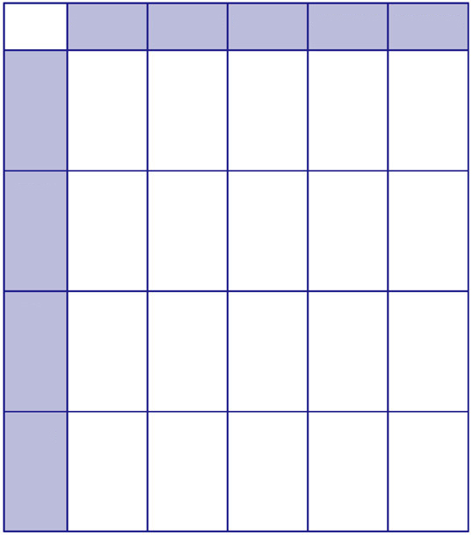
Item 4
Item 3
Item 2
Item 1
Attribute 5
Attribute 4
Attribute 3
Attribute 2
Attribute 1

Basic Thoughts Organizer

Brackets

Before/After Graphic Organizer

Subject ____________________________________________________________________

Before
After

Cause and Effect Graphic Organizer

Cause
Cause
Cause
Effect
Effect
Effect
Event

Cause and Effect Graphic Organizer

Topic/Subject:

Causes  (Because of . . . ) | Effects  (. . . these conditions result)

Cause and Effect: Multiple Causes

Causes
Effect

Cause and Effect: Multiple Effects
Effects
Cause
Effects

Characterization
Directions: One way in which an author develops characters is through what is said about them. As you read, consider what is said about the main character. First, write the character’s name in the center. Second, in one of the satellite bubbles, write what that character says about himself/herself. Third, in the remaining bubbles, record what other characters say about the main character.

Characterization

This chart shows five ways in which we learn about the main character. Next to each of the five ways in which character is revealed, give a specific example to illustrate. In the third column, explain what you learned about the character from this example.

Ways character is revealed | Example | What you learned about the character from this example
Character’s speech
Character’s appearance
Character’s private thoughts
How other characters feel about the character and react to the character
Character’s actions

Compare and Contrast

with regard to

Indicate which items are similar and which are different.

Comparison Graphic Organizer

Subject __________________________________________________________

Features of Subject A | Features of Subject B

Circle the similarities and underline the differences.

Conflict Dissection
Directions: Conflicts usually arise when someone wants something or wants something to happen and for some reason it does not. Use the chart below to identify the different conflicts and outcomes based on the text you are reading.

SOMEONE | WANTED/BECAUSE | BUT | SO
The American colonies | Freedom and independence from Great Britain because they felt oppressed by taxation without representation | Great Britain wanted to maintain control over the colonies because they were an economic asset | The American revolution began in 1776, which led to American Independence

Fact and Opinion

Topic ___________________________________________________________

Statement | Fact | Opinion

Fact and Opinion

Write your topic/task at the top of the page. Add details to each column.

Fact

Opinion

Flow Chart Model

Five W s

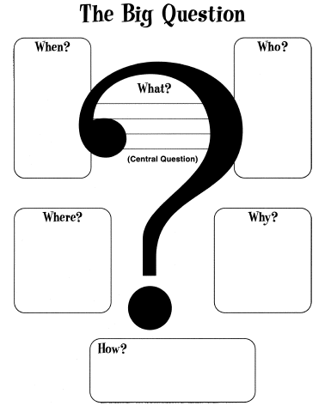

Four-Square Perspective
Examine a topic or issue from different points of view and synthesize your conclusions, connections, and questions on the following chart. First identify your issue by describing it and placing the main idea in the center rectangle. Then brainstorm four different perspectives, writing your thoughts in each of the four quadrants. Finally, synthesize what you concluded in the bottom section.

Different Perspectives on:
Conclusions / Connections / Questions / Realizations . . .

The Herringbone

Supporting Ideas

Main Idea

Idea – Details . . .

Add details about your idea.

Idea Details

Create a paragraph
With just a few changes, the idea and supporting details can be combined into a paragraph.
___________________________________________________________________________________
___________________________________________________________________________________
___________________________________________________________________________________
___________________________________________________________________________________
___________________________________________________________________________________
___________________________________________________________________________________
___________________________________________________________________________________
___________________________________________________________________________________

Life Map
In each of the shapes, e.g., squares, circles, triangles, etc. list an important event related to your life/work experience.

Begin

KWL Chart - Revised

What I Know for Sure About This Topic | What I Think I Know, But Am Not Sure About This Topic | What I Would Like to Learn About This Topic | Connections Between This Topic and Other Things I Know

Main Idea Graphic Organizer

Main Idea
Main Idea
Details
Details
Details
Main Idea

Organization: Timeline

Task ___________________________________________________

T-Chart

Like/Dislike
Things you like and things you dislike.

Typical/Unusual
Typical life experiences and unusual life experiences.

Fun/Have To
Things you do for fun and things you do because you have to do them.

Change/Stay the Same
Things you want to change and things you want to stay the same.

Regret/Proud Of
Things you regret and things of which you are proud.

Persuasion Map
Write your goal in the first box. Write three reasons for your goal in the next boxes. List facts and examples in the branching boxes.
fact/example
fact/example
fact/example
fact/example
fact/example
fact/example
fact/example
fact/example
fact/example
Reason 1
Reason 2
Reason 3
Goal

Pre-Reading Template for Texts/Books

Title:
Author:
Read the title. What do you think the book will be about?
After flipping through the pages, what can you learn about the setting?
After flipping through the pages, what can you learn about the characters?
After flipping through the pages, what can you learn about the plot or conflict?
Explain what you think of when you scan this book. Does it remind you of another book you have read?
Are you excited to read this book? What questions do you hope get answered?

Process Organizer

Steps in a Process Organizer
Step 1

Step 2

Step 3

Step 4

Step 5

Pros and Cons Scale

The Issue:

Pros Cons

Pros and Cons: Solving a Problem
The Problem:

Possible Solutions | Consequences  What will happen if I adopt this solution? | Pro  or  Con? | Value  How important is the consequence? Why?

The Best Solution:

Problem/Solution

Problem:

Causes of the Problem

Possible Solutions

Problem/Solution Chart

Problem/Solution requires that you identify a problem and consider multiple solutions and possible results.

Who
What?

Why?

Problem

Attempted Solutions Results

- 1.
- 2.
- 3.

Solution

End Results

Sequence Chart

List steps or events in time order.

Topic/Task:

First

Next

Next

Next

Next

Next

Next

Next

Next

Last

Spider Map

text
text

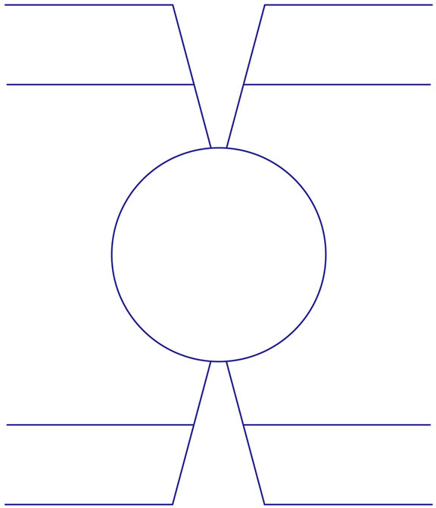
text
text
text
text
text
text
TOPIC

Text Connections

Directions: Use the chart below to make text-to-self, text-to-world, and world-to-self connections to the essential question.

Essential Question: ________________________________________________

Text
Self
World
Text-to-Self
Text-to-World
World-to-Self
Text-Self-World

Time-Order Chart
Write the topic/task in the center square. Write events in the boxes and details on the branching lines.

Event 1
Event 3
Event 2
Event 4
Topic

Tree

Use the following to help you connect different ideas and details about a topic/task.

Title or Topic

Venn Diagram: Two Circles

Topic ___________________________________________________________

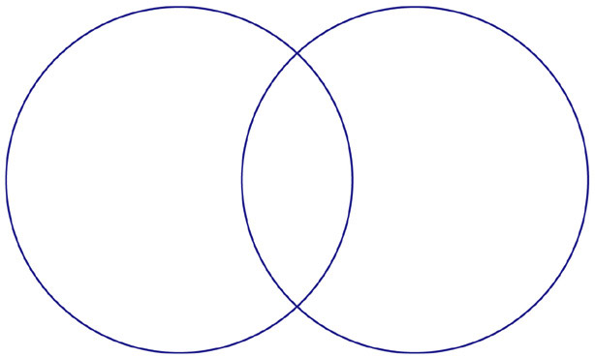
Title
Title
Title

Venn Diagram: Three Circles

Topic ___________________________________________________________

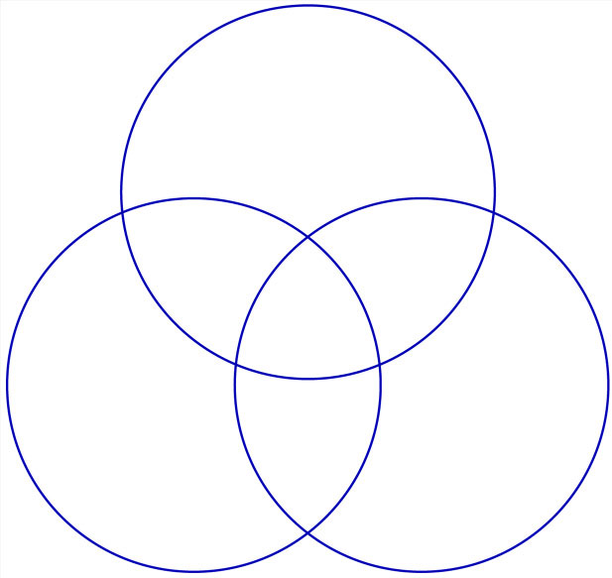
Title
Title
Title
Title
Title
Title
Title

Venn Diagram (Modern)

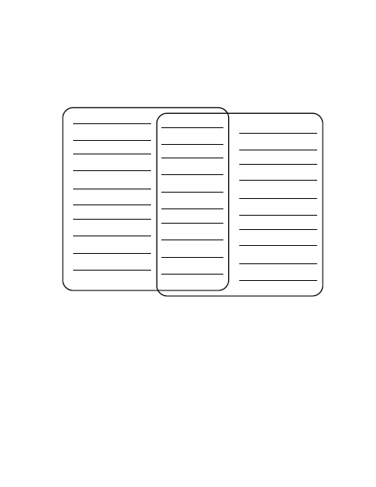

Verbal and Visual Word Association (Barton & Heidema, 2002)

Vocabulary Term(s) | Visual Representation
Definitions(s) | Personal Association or a Characteristic

Viewpoints and Actions

Viewpoints of Belief Actions

Web

Use the following organizer to develop your ideas or concepts. Identify your topic or task in the middle box. Add ideas about the topic/task in each of the circles.

Vocabulary – Frayer Model

What – Why – How Chart

What Why How
What do you think? Why do you think it? How do you know?

This is your opinion | This is your reason | This is your evidence or examples

Peha, Steve. The Writing Teacher’s Strategy Guide. (1995-2010). Teaching That Makes Sense, Inc.

