Session 3 Worksheet: Integrated Science and Mathematics Lesson
- Justin and Mario lives around Blackwater, FL and Highway Creek, FL respectively. Both students have been studying saltwater temperatures of the Gulf of Mexico near their areas between the months of January and August.

Which of the following is the best statement of hypothesis for their study?

- As time goes by, the average saltwater temperatures east of the Gulf of Mexico increases.
- The average saltwater temperature east of the Gulf of Mexico is directly proportional to time.
- As time goes by, the average saltwater temperatures of the East side of the Gulf of Mexico increases linearly between the months of January and August.
- The average saltwater temperature east of the Gulf of Mexico increases at a constant rate for a specific period of time in a year.

- Justin has been studying saltwater temperatures of the Gulf of Mexico near Little Blackwater, FL between the months of January and August. Below is a record of his observations.

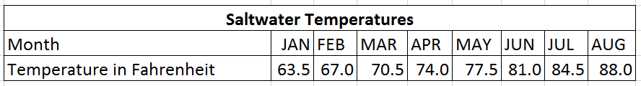
- Discuss the important pieces of information students should consider in this situation.

- Describe the relationship between the two quantities being studied by Justin.

- Describe the rate of temperature versus time in Justin’s observation.

- Mario has been studying saltwater temperatures of the Gulf of Mexico near Highway Creek, FL between the months of January and August. Below is a record of his observations.
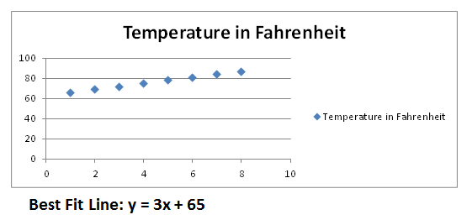
- Discuss the important pieces of information students should consider in this situation.

- Describe the relationship between the two quantities being studied by Mario.

- Describe the rate of temperature versus time in Mario’s observation.

- Use the area below to represent the data as a scatter plot.

- Justin has been studying saltwater temperatures of the Gulf of Mexico near Little Blackwater, FL between the months of January and August. Below is a record of his observations.

- Write a function that best fits Justin’s data.

- Using this function predict the average temperature on June 30 (middle of June and July).

- Mario and Justin found out about a startup company that wants to invest in a tropical or subtropical location where they could grow a particular species of coral. This coral is very sensitive to dramatic variations in saltwater temperature. Based on the observation models below by Justin and Mario, which area would the startup company most likely invest in?

Justin’s Observation: Little Blackwater, FL

Mario’s Observation: Highway Creek, FL
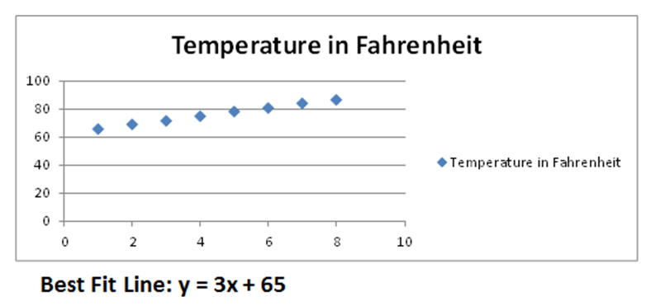

- If you are an avid supporter of this research study, write a brief letter of recommendation to the president of the startup company as to where they should invest based on the results of Justin and Mario’s experiment.

Date:

_________________________
_________________________
_________________________

Dear _________________________:
______________________________________________________________________
______________________________________________________________________
______________________________________________________________________
______________________________________________________________________
______________________________________________________________________
______________________________________________________________________
______________________________________________________________________
______________________________________________________________________
______________________________________________________________________

Sincerely,
___________________________

